**Web Technology Project**

**Homepage Code(with .php Extension):**

<?php

session_start();

if(isset($_SESSION['user_id'])){

$point=$_SESSION['user_id'];

$urladd="logout.php";

$npoint="Logout";

}

else{

$point="Login";

$urladd="Form.html";

$npoint="Login";

}

?>

<html>

<head>

<title>

Homepage

</title>

<style>

.dropbtn {

background-color: rgb(0, 0, 0);

color: white;

padding: 16px;

font-size: 16px;

border: 2;

}

.dropdown {

position: relative;

display: inline-block;

}

.dropdown-content {

display: none;

position: absolute;

background-color: #f1f1f1;

min-width: 160px;

box-shadow: 0px 8px 16px 0px rgba(0,0,0,0.2);

z-index: 1;

}

.dropdown-content a {

color: black;

padding: 12px 16px;

text-decoration: none;

display: block;

}

.alignleft {

float:left;

}

.alignright {

float:right;

}

.dropdown-content a:hover {background-color: rgb(255, 255, 255);}

.dropdown:hover .dropdown-content {display: block;}

.dropdown:hover .dropbtn {background-color: #000000;}

</style>

</head>

<body background="https://images.wallpaperscraft.com/image/fractal_lines_glare_152652_1920x1080.jpg">

<hr>

<p style="Color:white; font-size:25; text-align:left; image-resolution:1000"><a href="home.php"><img src="https://encrypted-tbn0.gstatic.com/images?q=tbn%3AANd9GcT_O9EvmdMKu3CtWz5K0scG6yObxkkGp4upWe7tM55u73xWK6Fe" height=100 width=200></a><i>“Where words leave off, music begins.”-<u>Heinrich Heine</u>.</i></p>

<hr>

<div>

<div class="dropdown">

<input type="button" class="dropbtn" value="Instrument Type">

<div class="dropdown-content">

<a href="StringedInstruments.html"><img src="https://www.newsservice.org/getimage.php?p=c2dpZD02NTg0NCZzaWQ9MQ==" height=150 width=200>Stringed Instruemnts</a>

<a href="PersussionInstruments.html"><img src="https://farm3.static.flickr.com/2858/33441334052_07df10acdc_b.jpg"height=150 width=200>Percussion Instruments</a>

<a href="WindInstruments.html"><img src="https://encrypted-tbn0.gstatic.com/images?q=tbn%3AANd9GcSoxYYUeoySZjCc77XaBjha4SChf7fjV5kAyFb3xQ0H9tWBOrFK" height=150 width=200>Wind Instruments</a>

<a href="ElectronicInstruments.html"><img src="https://encrypted-tbn0.gstatic.com/images?q=tbn%3AANd9GcT-ZsjFDJ3wW8Ev1rfDaEHLGBFicd8MnoREvIx4E8J4OpqNKwIL" height=150 width=200>Electronic Instruments</a>

</div>

</div>

<input class="dropbtn" id="login" type="button" onclick="location.href='<?php echo $urladd ?>'" target="_blank" value="<?php echo $point ?>" onmouseover="document.getElementById('login').value='<?php echo $npoint?>'" onmouseleave="document.getElementById('login').value='<?php echo $point?>'" style="position: absolute; right:345">

<input class="dropbtn" type="button" onclick="location.href='RegForm.html'" target="_blank" value="Register" style="position: absolute; right:240">

<input class="dropbtn" type="button" onclick="location.href='About.html'" target="_blank" value="About" style="position: absolute; right:152">

<input class="dropbtn" type="button" onclick="location.href='Contact.html'" target="_blank" value="Contact" style="position: absolute; right:50">

<!--<input class="dropbtn" type="button" onclick="" value="" style="position:Fixed;right: 100 ">-->

</div>

<hr>

<iframe width="700" height="340" src="https://www.youtube-nocookie.com/embed/ZldWzf16kFg" frameborder="0" allow="accelerometer; autoplay; encrypted-media; gyroscope; picture-in-picture" allowfullscreen></iframe>

<iframe align=right width="700" height="340" src="https://www.youtube-nocookie.com/embed/29EacYXQMlg" frameborder="0" allow="accelerometer; autoplay; encrypted-media; gyroscope; picture-in-picture" allowfullscreen></iframe>

<br>

<br>

<iframe width="700" height="340" src="https://www.youtube-nocookie.com/embed/0xxeRFEP1Y4" frameborder="0" allow="accelerometer; autoplay; encrypted-media; gyroscope; picture-in-picture" allowfullscreen></iframe>

<iframe align= right width="700" height="340" src="https://www.youtube-nocookie.com/embed/2yXm_3dEBNA" frameborder="0" allow="accelerometer; autoplay; encrypted-media; gyroscope; picture-in-picture" allowfullscreen></iframe>

<br>

<hr>

<br>

<center><iframe width="720" height="400" src="https://www.youtube-nocookie.com/embed/6i0a7RDPkM8" frameborder="0" allow="accelerometer; autoplay; encrypted-media; gyroscope; picture-in-picture" allowfullscreen></iframe></center>

<hr>

</body>

</html>

**Homepage Screenshot:**

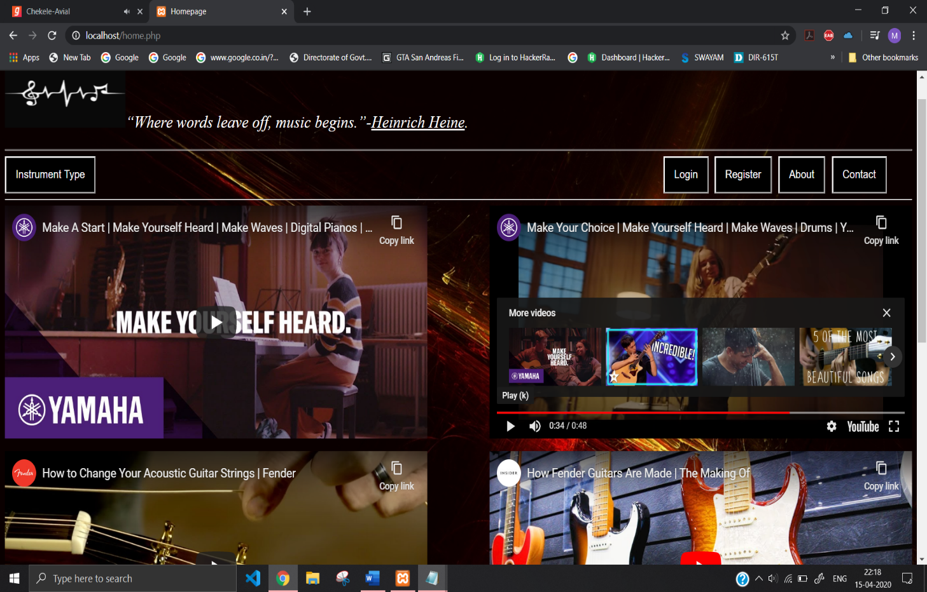

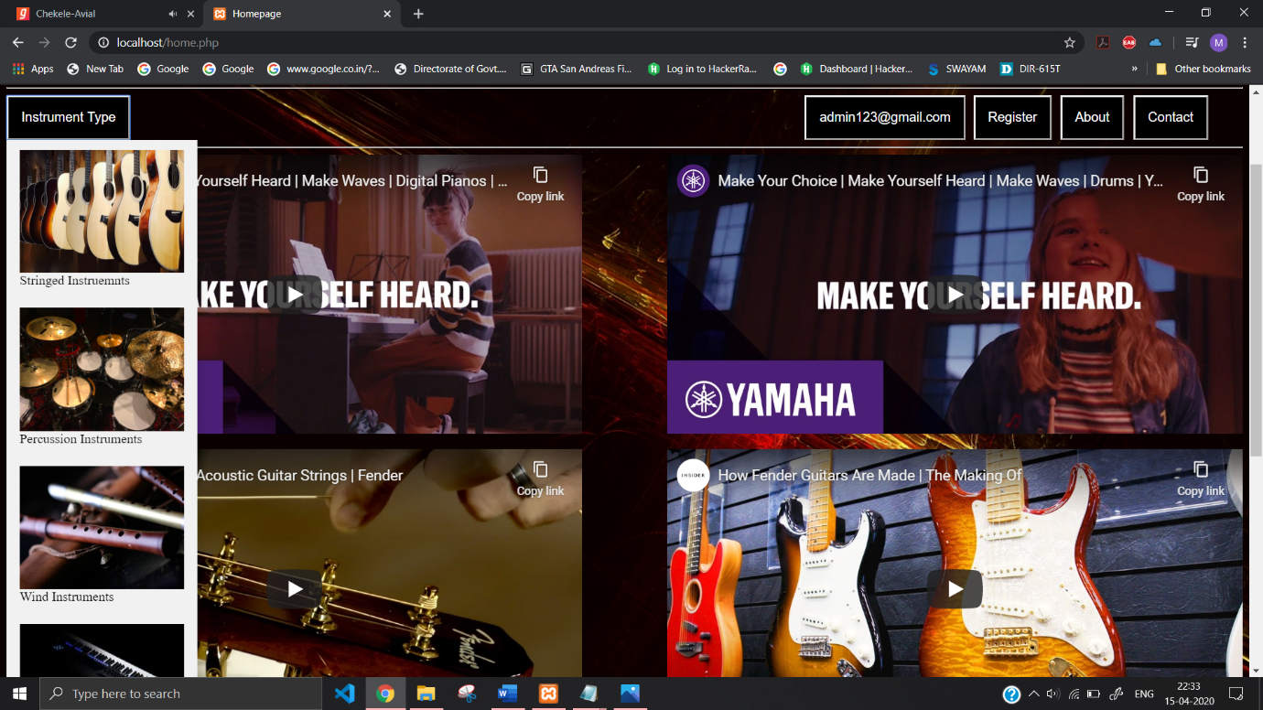

**Registration page(with .html extension):**

<html>

<head>

<title>Registration</title>

<style>

body{

background-image:url('https://images.wallpaperscraft.com/image/circles_highlights_background_form_size_47438_2560x1600.jpg');

background-repeat:no-repeat;

background-attachment:fixed;

background-size:100% 110%;

}

.dropbtn {

background-color: rgb(0, 0, 0);

color: white;

padding: 16px;

font-size: 16px;

border: 2;

}

</style>

</head>

<body><big>

<p style="Color:white; font-size:25; text-align:left; image-resolution:1000"><a href="home.html"><img src="https://encrypted-tbn0.gstatic.com/images?q=tbn%3AANd9GcT_O9EvmdMKu3CtWz5K0scG6yObxkkGp4upWe7tM55u73xWK6Fe" height=100 width=200></a>

<hr>

<div>

<input class="dropbtn" type="button" onclick="location.href='Form.html'" target="_blank" value="Login" style="position: absolute; right:345">

<input class="dropbtn" type="button" onclick="location.href='RegForm.html'" target="_blank" value="Register" style="position: absolute; right:240">

<input class="dropbtn" type="button" onclick="location.href='About.html'" target="_blank" value="About" style="position: absolute; right:152">

<input class="dropbtn" type="button" onclick="location.href='Contact.html'" target="_blank" value="Contact" style="position: absolute; right:50">

<!--<input class="dropbtn" type="button" onclick="" value="" style="position:Fixed;right: 100 ">-->

</div>

<br>

<br>

<br>

<hr>

<form action="connect.php" method=POST>

<fieldset>

<legend><big>Registeration</big></legend>

<table>

<tr>

<td>First_Name:</td>

<td> <input type="text" name="First_Name" placeholder="First Name" size="30" required></td>

</tr>

<tr>

<td>Last_Name:</td>

<td><input type="text" name="Last_Name" placeholder="Last_Name" size="30" required></td>

</tr>

<tr>

<td>Father's_Name:</td>

<td> <input type="text" name="Father_Name" placeholder="Father's_Name" size="30" required></td>

</tr>

<tr>

<td>user_id:</td>

<td><input type="email" name="user_id" id="user_id" required></td>

</tr>

<tr>

<td>password:</td>

<td><input type="password" name="password" id="myInput" ondbclick="validatePassword()">

&nbsp;&nbsp;<input type="checkbox" onclick="myFunction2()">Show password

&nbsp;&nbsp;<button onclick="validatePassword()" >Check Your password</button></td>

</tr>

<tr>

<td>Ph_No.:</td>

<td>

<select>

<option>+91</option>

<option>+021</option>

<option>+214</option>

</select>

<input type="tel" name="Ph_No" placeholder="Ph_No" maxlength="10" required>

<!--pattern="[0-9]{4}-[0-9]{3}-[0-9]{3}"-->

</input>

</td>

</tr>

<tr>

<td>Date of Birth:</td>

<td><input type="date" name="date" placeholder="date of Birth" required></td>

</tr>

<tr>

<td>Gender:</td>

<td>Male:

<input type="radio" name="gender" value="male" checked>

Female:

<input type="radio" name="gender" value="female">

Others:

<input type="radio" name="gender" value="other"></td>

</tr>

<tr>

<td>Address</td>

<td><textarea rows="5" cols="50" name="Address" id="Address" placeholder="Address"></textarea>

</td>

</tr>

<tr>

<td>Address Proof</td>

<td>

<label for="fileselect">Upload:</label>

<input type="file" name="upload" id="fileselect">

</td>

</tr>

<br>

<tr>

<td>

Country:

</td>

<td>

<select id="Country" name="Country" required>

<option>Select from the below List</option>

<option value="India">India</option>

<option value="US">US</option>

<option value="UK">India</option>

</select>

</td>

</tr>

</table>

<br><br>

<center> <a href="https://www.termsfeed.com/blog/wp-content/uploads/2019/04/terms-and-conditions-template.pdf">Click here to see the terms and conditions</a><br>

<input type="checkbox" name="I agree all the terms and conditions" value="checkbox" required>

I agree all the terms and conditions.</center>

<center>

<input type="reset" value="Reset">

<a href="Form.html">

<input type="submit" name:"submit" value="Submit" ></a>

</center>

</fieldset>

<br>

<center>

Rate the Form:

<input type="range" name="points" min="0" max="10">

<input type="submit">

</center>

</form>

<script>

function myFunction2() {

var x = document.getElementById("myInput");

if (x.type == "password") {

x.type = "text";

}

else

{

x.type = "password";

}

}

function myfunction1()

{

alert('logged in');

}

function validatePassword() {

var p = document.getElementById('myInput').value,

errors = [];

if (p.length < 8) {

errors.push("must be at least 8 characters");

}

if (p.search(/[a-z]/i) < 0) {

errors.push("must contain at least one letter.");

}

if (p.search(/[0-9]/) < 0) {

errors.push("must contain at least one digit.");

}

if (errors.length > 0) {

alert(errors.join("\n"));

return false;

}

return true;

}

</script>

</big>

</body>

</html>

**Registration page Screenshot:**

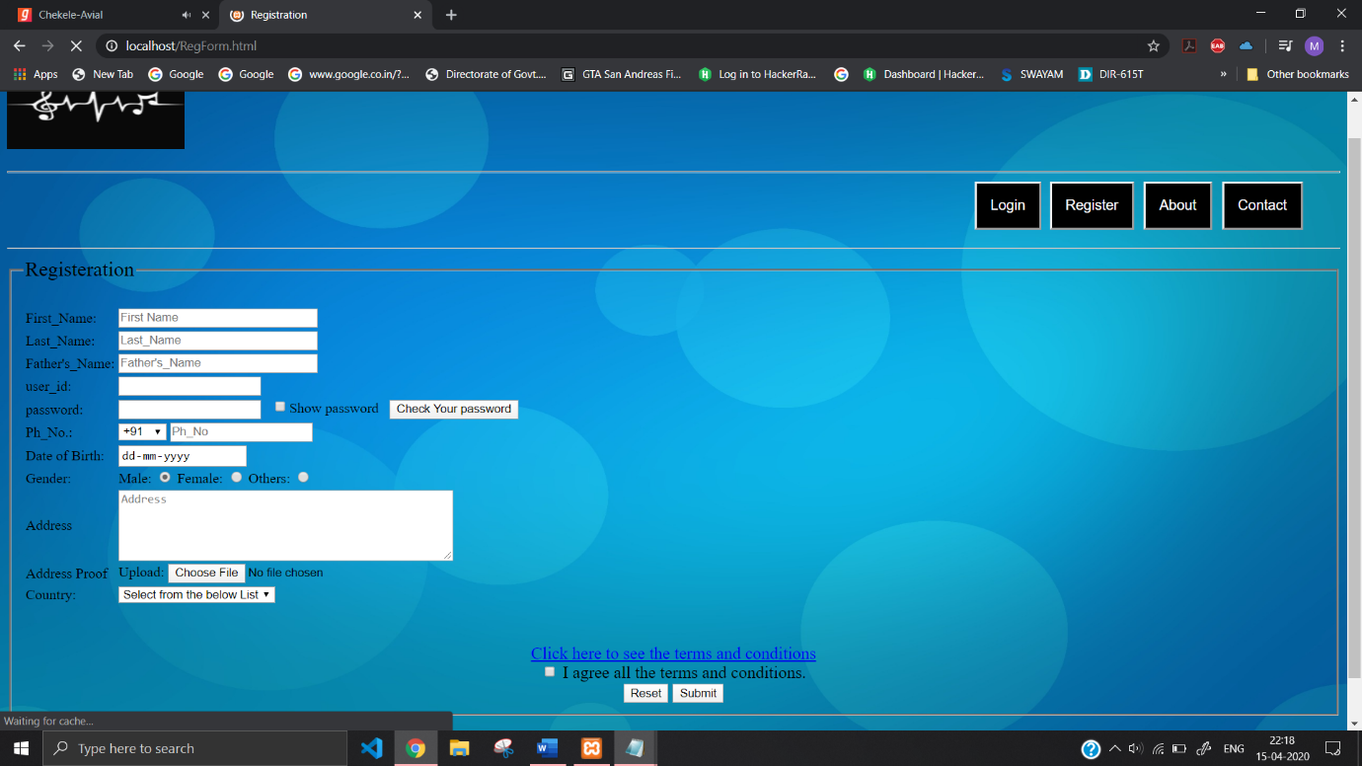

**Registration page to database connectivity php code:**

<?php

$First_Name=$_POST['First_Name'];

$Last_Name=$_POST['Last_Name'];

$Father_Name=$_POST['Father_Name'];

$user_id=$_POST['user_id'];

$password=$_POST['password'];

$Ph_No=$_POST['Ph_No'];

$date=$_POST['date'];

$gender=$_POST['gender'];

$Address=$_POST['Address'];

$Country=$_POST['Country'];

//DB code

$conn=new mysqli('localhost','root','','project');

//$conn=new mysqli('url','dbusername','xamppwd','dbname')//

if($conn->connect_error){

die('Connection Failed : '.$conn->connect_error);

}

else{

$stmt=$conn->prepare("insert into registration(First_Name,Last_Name,Father_Name,user_id,password,Ph_No,date,gender,Address,Country) values(?,?,?,?,?,?,?,?,?,?)"); //query//

//bind to specify datatypes (i-int,d-double,s-string,b-BLOB)//

$stmt->bind_param("sssssissss",$First_Name,$Last_Name,$Father_Name,$user_id,$password,$Ph_No,$date,$gender,$Address,$Country);

$stmt->execute(); //executing query//

//echo "registered successfully...";

echo "registered successfully";

header("Refresh: 2; URL=home.php");

$stmt->close();

$conn->close();

exit;

}

?>

**Login form code(with .html extension):**

<html>

<head>

<title>Login</title>

<style>

.button {

background-color: white;

color:black;

text-align:center;

font-size:16px;

cursor:pointer;

}

button:hover{

background-color:aqua;

color:red;

}

</style>

</head>

<body background="https://images.wallpaperscraft.com/image/strip_line_geometry_152638_1920x1080.jpg">

<hr>

<a href="home.php"><img src="https://encrypted-tbn0.gstatic.com/images?q=tbn%3AANd9GcT_O9EvmdMKu3CtWz5K0scG6yObxkkGp4upWe7tM55u73xWK6Fe" height=100 width=200></a>

<hr>

<br>

<br>

<br>

<form action="login.php" method="POST">

<fieldset>

<legend><big>Login</big></legend>

<center>

user_id:

<input type="email" name="iuser_id" id="user_id" required>

<br>

<br>

password:

<input type="password" name="ipassword" id="myInput" ondbclick="validatePassword()">

<br>

<br>

<input type="checkbox" onclick="myFunction2()">Show password

<br>

<br>

<input type="submit" name="submit" value="Login" id="submit" onclick="validatePassword()">

<br>

<br>

<hr>

<a href="RegForm.html">Are you a new user? Click to register</a>

<br>

</center>

</fieldset>

</form>

<script>

function myFunction2() {

var x = document.getElementById("myInput");

if (x.type == "password") {

x.type = "text";

}

else

{

x.type = "password";

}

}

function validatePassword() {

var p = document.getElementById('myInput').value,

errors = [];

if (p.length < 8) {

errors.push("must be at least 8 characters");

}

if (p.search(/[a-z]/i) < 0) {

errors.push("must contain at least one letter.");

}

if (p.search(/[0-9]/) < 0) {

errors.push("must contain at least one digit.");

}

if (errors.length > 0) {

alert(errors.join("\n"));

return false;

}

return true;

}

</script>

</body>

</html>

**Login Page Screenshot:**

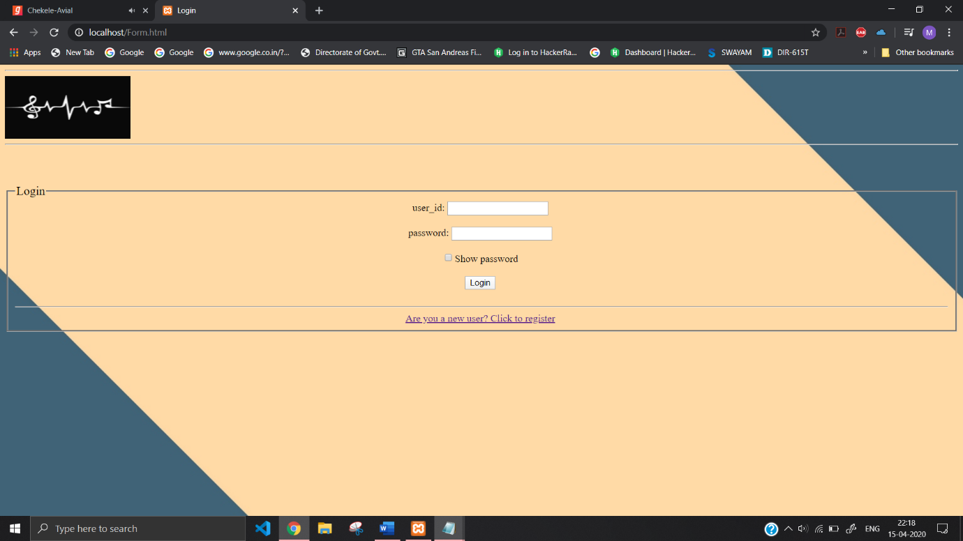

**Login Functionality php code:**

<?php

$iuser_id=$_POST['iuser_id'];

$ipassword=$_POST['ipassword'];

//to prevent sql injection

$iuser_id=stripcslashes($iuser_id);

$ipassword=stripcslashes($ipassword);

session_start();

//connect to server and db

$conn=new mysqli('localhost','root','','project');

if($conn->connect_error){

die('Connection Failed : '.$conn->connect_error);

}

else{

if(isset($_POST['submit']))

{

$uname = mysqli_real_escape_string($conn,$_POST['iuser_id']);

$password = mysqli_real_escape_string($conn,$_POST['ipassword']);

if ($uname != "" && $password != "")

{

$sql_query = "select count(*) as user_id from registration where user_id='".$uname."' and password='".$password."'";

$result = mysqli_query($conn,$sql_query);

$row = mysqli_fetch_array($result);

$count = $row['user_id'];

if($count > 0){

$_SESSION['user_id'] = $uname;

//header('Location: home.php');

echo "hello " . $_SESSION['user_id'];

header('Refresh: 2; URL=home.php');

}else

{

echo "Invalid username or password try again";

header('Refresh: 2; URL=Form.html');

}

$conn->close();

}

}

}

?>

**After Login UserID appers instead of Login Button:**

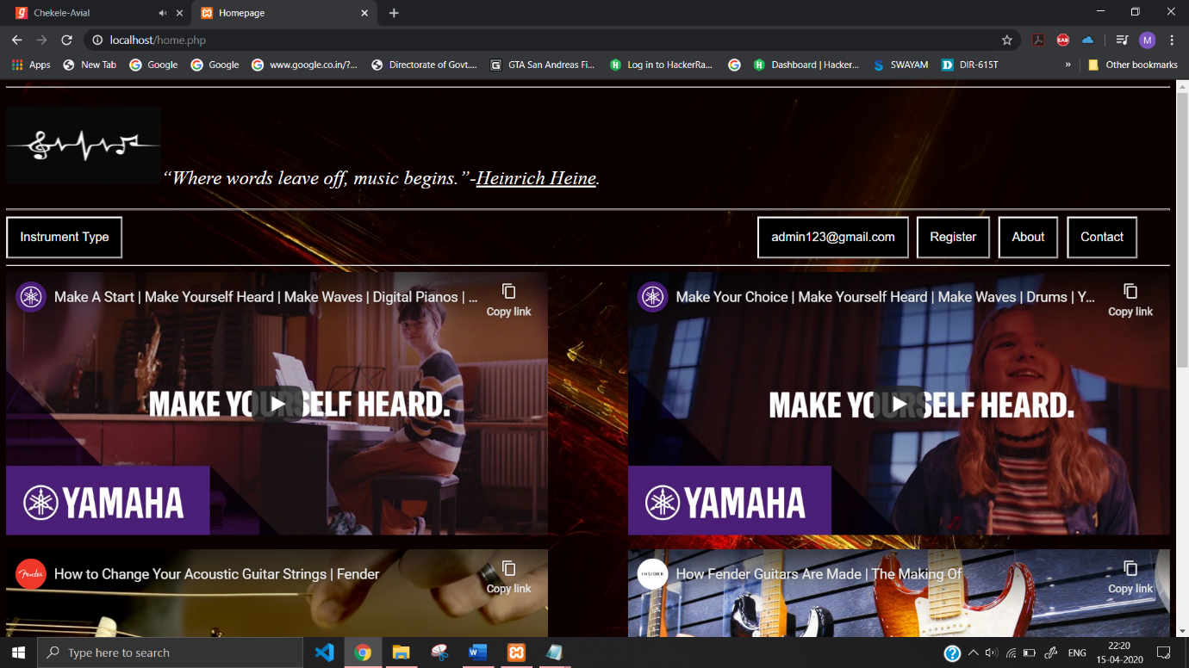

**Logout functionality php code:**

<?php

session_start();

if(isset($_SESSION['user_id']))

{

session_destroy();

echo "You are logged-out";

header('Refresh: 2; URL=home.php');

}

else{

echo "<script>location.href='home.php'</script>";

}

?>

**When you hover on the button instead of UserID Logout Appears:**

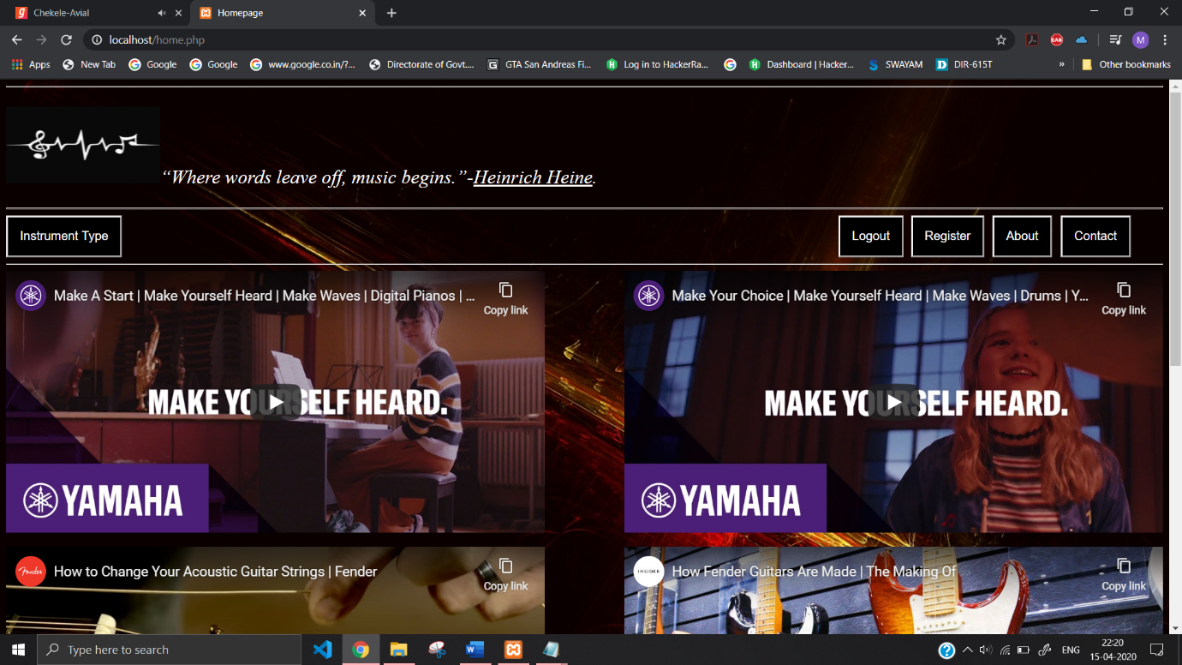

**About page code(.html Extension):**

<html>

<head>

<title>

About us!!

</title>

<style>

.dropbtn {

background-color: rgb(0, 0, 0);

color: white;

padding: 16px;

font-size: 16px;

border: 2;

}

</style>

</head>

<body background="https://images.wallpaperscraft.com/image/boat_clouds_mountains_152754_1920x1080.jpg" height="100%">

<a href="home.php"><img src="https://encrypted-tbn0.gstatic.com/images?q=tbn%3AANd9GcT_O9EvmdMKu3CtWz5K0scG6yObxkkGp4upWe7tM55u73xWK6Fe" height=100 width=200></a>

<hr>

<div>

<input class="dropbtn" type="button" onclick="location.href='Form.html'" target="_blank" value="Login" style="position: absolute; right:345">

<input class="dropbtn" type="button" onclick="location.href='RegForm.html'" target="_blank" value="Register" style="position: absolute; right:240">

<input class="dropbtn" type="button" onclick="location.href='About.html'" target="_blank" value="About" style="position: absolute; right:152">

<input class="dropbtn" type="button" onclick="location.href='Contact.html'" target="_blank" value="Contact" style="position: absolute; right:50">

<!--<input class="dropbtn" type="button" onclick="" value="" style="position:Fixed;right: 100 ">-->

</div>

<br>

<br>

<br>

<hr>

<fieldset>

<legend><i>What is music??</i></legend>

<p align="center">Music is an art form and cultural activity whose medium is sound organized in time. General definitions of music include common elements such as pitch (which governs melody and harmony), rhythm (and its associated concepts tempo, meter, and articulation), dynamics (loudness and softness), and the sonic qualities of timbre and texture (which are sometimes termed the "color" of a musical sound). Different styles or types of music may emphasize, de-emphasize or omit some of these elements. Music is performed with a vast range of instruments and vocal techniques ranging from singing to rapping; there are solely instrumental pieces, solely vocal pieces (such as songs without instrumental accompaniment) and pieces that combine singing and instruments. The word derives from Greek μουσική (mousike; "art of the Muses"). See glossary of musical terminology.

In its most general form, the activities describing music as an art form or cultural activity include the creation of works of music (songs, tunes, symphonies, and so on), the criticism of music, the study of the history of music, and the aesthetic examination of music. Ancient Greek and Indian philosophers defined music as tones ordered horizontally as melodies and vertically as harmonies. Common sayings such as "the harmony of the spheres" and "it is music to my ears" point to the notion that music is often ordered and pleasant to listen to. However, 20th-century composer John Cage thought that any sound can be music, saying, for example, "There is no noise, only sound.

The creation, performance, significance, and even the definition of music vary according to culture and social context. Indeed, throughout history, some new forms or styles of music have been criticized as "not being music", including Beethoven's Grosse Fuge string quartet in 1825, early jazz in the beginning of the 1900s and hardcore punk in the 1980s. There are many types of music, including popular music, traditional music, art music, music written for religious ceremonies and work songs such as chanteys. Music ranges from strictly organized compositions–such as Classical music symphonies from the 1700s and 1800s, through to spontaneously played improvisational music such as jazz, and avant-garde styles of chance-based contemporary music from the 20th and 21st centuries.

Music can be divided into genres (e.g., country music) and genres can be further divi ded into subgenres (e.g., country blues and pop country are two of the many country subgenres), although the dividing lines and relationships between music genres are often subtle, sometimes open to personal interpretation, and occasionally controversial. For example, it can be hard to draw the line between some early 1980s hard rock and heavy metal. Within the arts, music may be classified as a performing art, a fine art or as an auditory art. Music may be played or sung and heard live at a rock concert or orchestra performance, heard live as part of a dramatic work (a music theater show or opera), or it may be recorded and listened to on a radio, MP3 player, CD player, smartphone or as film score or TV show.

In many cultures, music is an important part of people's way of life, as it plays a key role in religious rituals, rite of passage ceremonies (e.g., graduation and marriage), social activities (e.g., dancing) and cultural activities ranging from amateur karaoke singing to playing in an amateur funk band or singing in a community choir. People may make music as a hobby, like a teen playing cello in a youth orchestra, or work as a professional musician or singer. The music industry includes the individuals who create new songs and musical pieces (such as songwriters and composers), individuals who perform music (which include orchestra, jazz band and rock band musicians, singers and conductors), individuals who record music (music producers and sound engineers), individuals who organize concert tours, and individuals who sell recordings, sheet music, and scores to customers.</p>

</fieldset>

<fieldset>

<legend>Musical Instruments</legend>

<p>

A musical instrument is an instrument created or adapted to make musical sounds. In principle, any object that produces sound can be considered a musical instrument—it is through purpose that the object becomes a musical instrument. The history of musical instruments dates to the beginnings of human culture. Early musical instruments may have been used for ritual, such as a trumpet to signal success on the hunt, or a drum in a religious ceremony. Cultures eventually developed composition and performance of melodies for entertainment. Musical instruments evolved in step with changing applications.

The date and origin of the first device considered a musical instrument is disputed. The oldest object that some scholars refer to as a musical instrument, a simple flute, dates back as far as 67,000 years. Some consensus dates early flutes to about 37,000 years ago. However, most historians believe that determining a specific time of musical instrument invention is impossible due to the subjectivity of the definition and the relative instability of materials used to make them. Many early musical instruments were made from animal skins, bone, wood of specified trees, and other non-durable materials.

Musical instruments developed independently in many populated regions of the world. However, contact among civilizations caused rapid spread and adaptation of most instruments in places far from their origin. By the Middle Ages, instruments from Mesopotamia were in maritime Southeast Asia, and Europeans played instruments originating from North Africa. Development in the Americas occurred at a slower pace, but cultures of North, Central, and South America shared musical instruments. By 1400, musical instrument development slowed in many areas and was dominated by the Occident.

Musical instrument classification is a discipline in its own right, and many systems of classification have been used over the years. Instruments can be classified by their effective range, their material composition, their size, etc. However, the most common academic method, Hornbostel–Sachs, uses the means by which they produce sound. The academic study of musical instruments is called organology.

</p>

</fieldset>

</body>

</html>

**About Page Screenshot:**

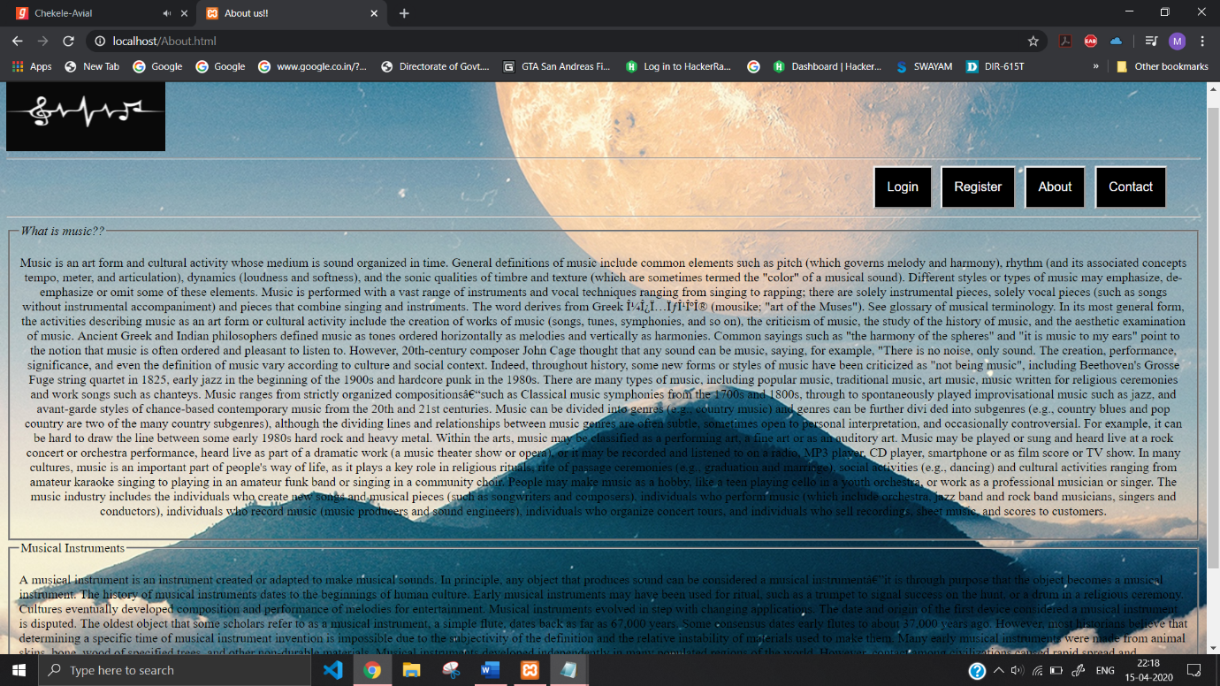

**Contact page code(.html Extension):**

<html>

<head>

<title>

Contact

</title>

<style>

body{

background-image:url('https://images.wallpaperscraft.com/image/circles_background_light_bright_74758_1920x1200.jpg');

background-repeat:no-repeat;

background-attachment:fixed;

background-size:100% 110%;

}

.dropbtn {

background-color: rgb(0, 0, 0);

color: white;

padding: 16px;

font-size: 16px;

border: 2;

}

</style>

</head>

<body>

<big>

<p style="Color:white; font-size:25; text-align:left; image-resolution:1000"><a href="home.php"><img src="https://encrypted-tbn0.gstatic.com/images?q=tbn%3AANd9GcT_O9EvmdMKu3CtWz5K0scG6yObxkkGp4upWe7tM55u73xWK6Fe" height=100 width=200></a>

<hr>

<div>

<input class="dropbtn" type="button" onclick="location.href='Form.html'" target="_blank" value="Login" style="position: absolute; right:345">

<input class="dropbtn" type="button" onclick="location.href='RegForm.html'" target="_blank" value="Register" style="position: absolute; right:240">

<input class="dropbtn" type="button" onclick="location.href='About.html'" target="_blank" value="About" style="position: absolute; right:152">

<input class="dropbtn" type="button" onclick="location.href='Contact.html'" target="_blank" value="Contact" style="position: absolute; right:50">

<!--<input class="dropbtn" type="button" onclick="" value="" style="position:Fixed;right: 100 ">-->

</div>

<br><br><br>

<hr>

<p align="center"><big>

This developed webiste is only for publicity.<br><br>

All the credits goes to the original developers.<br><br>

This webiste is only to provides convenience for the people to understand information related Musical Instruments.

</big>

</p>

</body>

</html>

**Contact Page Screenshot:**

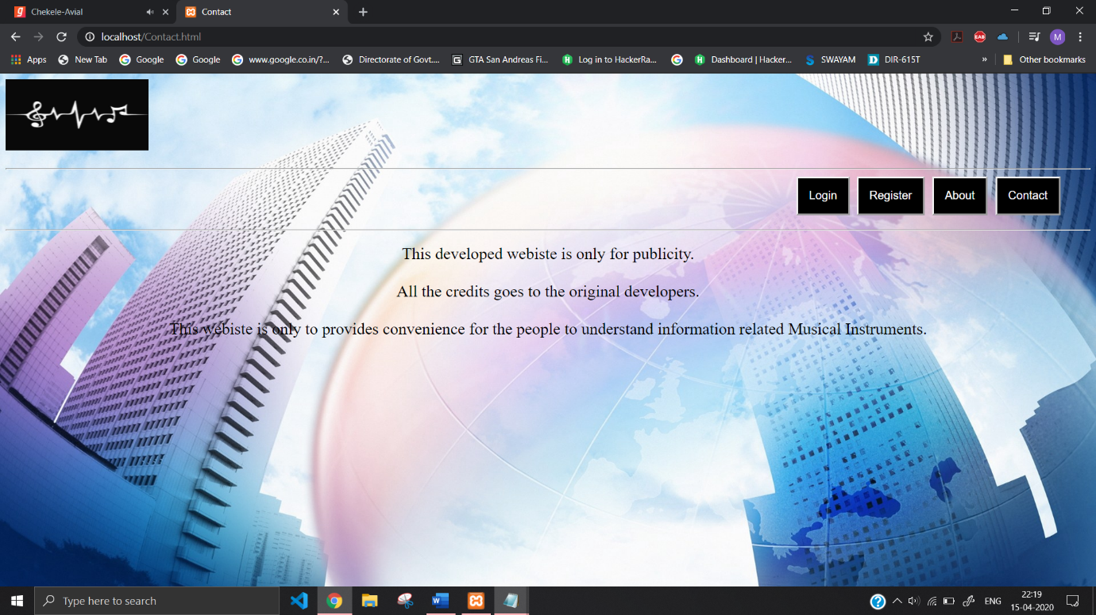

**Stringed Instrument html page:**

<html>

<head>

<title>

Stringed Instruments

</title>

<style>

body{

background-image:url('https://images.wallpaperscraft.com/image/guitar_close-up_house_80963_1280x720.jpg');

background-repeat:no-repeat;

background-attachment:fixed;

background-size:100% 110%;

font-size: 20px;

}

.dropbtn {

background-color: rgb(0, 0, 0);

color: white;

padding: 16px;

font-size: 16px;

border: 2;

}

</style>

</head>

<body>

<big>

<p style="Color:white; font-size:25; text-align:left; image-resolution:1000"><a href="home.php"><img src="https://encrypted-tbn0.gstatic.com/images?q=tbn%3AANd9GcT_O9EvmdMKu3CtWz5K0scG6yObxkkGp4upWe7tM55u73xWK6Fe" height=100 width=200></a>

<hr>

<div>

<input class="dropbtn" type="button" onclick="location.href='Form.html'" target="_blank" value="Login" style="position: absolute; right:345">

<input class="dropbtn" type="button" onclick="location.href='RegForm.html'" target="_blank" value="Register" style="position: absolute; right:240">

<input class="dropbtn" type="button" onclick="location.href='About.html'" target="_blank" value="About" style="position: absolute; right:152">

<input class="dropbtn" type="button" onclick="location.href='Contact.html'" target="_blank" value="Contact" style="position: absolute; right:50">

<!--<input class="dropbtn" type="button" onclick="" value="" style="position:Fixed;right: 100 ">-->

</div>

<br>

<br>

<hr>

<center><img src="https://www.orsymphony.org/globalassets/hero-images/instruments-of-the-orchestra/strings_pc-leah-nash_1900x600.jpg" width="1080px"></center>

<p>

String instruments, stringed instruments, or chordophones are musical instruments that produce sound from vibrating strings when the performer plays or sounds the strings in some manner.

Musicians play some string instruments by plucking the strings with their fingers or a plectrum—and others by hitting the strings with a light wooden hammer or by rubbing the strings with a bow. <br>In some keyboard instruments, such as the harpsichord, the musician presses a key that plucks the string.

With bowed instruments, the player pulls a rosined horsehair bow across the strings, causing them to vibrate. With a hurdy-gurdy, the musician cranks a wheel whose rosined edge touches the strings.<br>

Bowed instruments include the string section instruments of the Classical music orchestra (violin, viola, cello and double bass) and a number of other instruments (e.g., viols and gambas used in early music from the Baroque music era and fiddles used in many types of folk music). <br>All of the bowed string instruments can also be plucked with the fingers, a technique called "pizzicato".<br> A wide variety of techniques are used to sound notes on the electric guitar, including plucking with the fingernails or a plectrum, strumming and even "tapping" on the fingerboard and using feedback from a loud, distorted guitar amplifier to produce a sustained sound.<br> Some types of string instrument are mainly plucked, such as the harp and the electric bass. In the Hornbostel-Sachs scheme of musical instrument classification, used in organology, string instruments are called chordophones. Other examples include the sitar, rebab, banjo, mandolin, ukulele, and bouzouki.

In most string instruments, the vibrations are transmitted to the body of the instrument, which often incorporates some sort of hollow or enclosed area. <br>The body of the instrument also vibrates, along with the air inside it. <br>The vibration of the body of the instrument and the enclosed hollow or chamber make the vibration of the string more audible to the performer and audience. <br>The body of most string instruments is hollow. Some, however—such as electric guitar and other instruments that rely on electronic amplification—may have a solid wood body.

</p>

<p align="center">

<img src="https://encrypted-tbn0.gstatic.com/images?q=tbn%3AANd9GcTwZlG5njIcKy-ZxWVB70fNuFznFr_gE1liwZWR7zkdL4_Xsudf">

</p>

<p>

String instruments can be divided in three groups<br>

<b><u>Lutes</u></b> <br>

Instruments that support the strings via a neck and a bout ("gourd"), for instance a guitar, a violin, or a saz<br>

<b><u>Harps </u></b><br>

Instruments that contain the strings within a frame<br>

<b><u>Zithers</u></b><br>

Instruments that have the strings mounted on a body, frame or tube, such as a guqin, a cimbalom, an autoharp, harpsichord, a piano, or a valiha<br>

It is also possible to divide the instruments into categories focused on how the instrument is played.<br>

<b><u>Playing techniques</u></b><br>

Further information: List of string instruments<br>

An acoustic guitar being strummed.<br>

All string instruments produce sound from one or more vibrating strings, transferred to the air by the body of the instrument (or by a pickup in the case of electronically amplified instruments).<br> They are usually categorised by the technique used to make the strings vibrate (or by the primary technique, in the case of instruments where more than one may apply).<br> The three most common techniques are plucking, bowing, and striking.<br> An important difference between bowing and plucking is that in the former the phenomenon is periodic so that the overtones are kept in a strictly harmonic relationship to the fundamental.<br>

<b><u>Plucking</u></b><br>

Main article: Plucked string instrument<br>

Plucking is a method of playing on instruments such as the veena, banjo, ukulele, guitar, harp, lute, mandolin, oud, and sitar, using either a finger, thumb, or quills (now plastic plectra) to pluck the strings.<br>

Instruments normally played by bowing (see below) may also be plucked, a technique referred to by the Italian term pizzicato.<br>

<b><u>Bowing</u></b><br>

Main article: Bowed string instrument<br>

Bowing (Italian: arco) is a method used in some string instruments, including the violin, viola, cello, and the double bass (of the violin family), and the old viol family. <br>The bow consists of a stick with a "ribbon" of parallel horse tail hairs stretched between its ends. The hair is coated with rosin so it can grip the string; moving the hair across a string causes a stick-slip phenomenon, making the string vibrate, and prompting the instrument to emit sound.<br> Darker grades of rosin grip well in cool, dry climates, but may be too sticky in warmer, more humid weather.<br> Violin and viola players generally use harder, lighter-colored rosin than players of lower-pitched instruments, who tend to favor darker, softer rosin.<br>

The ravanahatha is one of the oldest string instruments. <br>Ancestors of the modern bowed string instruments are the rebab of the Islamic Empires, the Persian kamanche and the Byzantine lira.<br> Other bowed instruments are the rebec, hardingfele, nyckelharpa, kokyū, erhu, igil, sarangi and K'ni.<br> The hurdy-gurdy is bowed by a wheel. Rarely, the guitar has been played with a bow (rather than plucked) for unique effects.<br>

<b><u>Striking</u></b><br>

The third common method of sound production in stringed instruments is to strike the string. <br>The piano and hammered dulcimer use this method of sound production.<br> Even though the piano strikes the strings, the use of felt hammers means that the sound that is produced can nevertheless be mellow and rounded, in contrast to the sharp attack produced when a very hard hammer strikes the strings.<br>

Violin family string instrument players are occasionally instructed to strike the string with the stick of the bow, a technique called col legno.<br> This yields a percussive sound along with the pitch of the note.<br> A well-known use of col legno for orchestral strings is Gustav Holst's "Mars" movement from The Planets suite.<br>

<b><u></u></b>Other methods

The aeolian harp employs a very unusual method of sound production: the strings are excited by the movement of the air.<br>

Some instruments that have strings have an attached keyboard that the player presses keys on to trigger a mechanism that sounds the strings, instead of directly manipulating the strings. <br>These include the piano, the clavichord, and the harpsichord. With these keyboard instruments, strings are occasionally plucked or bowed by hand. <br>Modern composers such as Henry Cowell wrote music that requires that the player reach inside the piano and pluck the strings directly, "bow" them with bow hair wrapped around the strings, or play them by rolling the bell of a brass instrument such as a trombone on the array of strings.<br> However, these are relatively rarely used special techniques.

<b>Other keyed string instruments</b>, small enough for a strolling musician to play, include the plucked autoharp, the bowed nyckelharpa, and the hurdy-gurdy, which is played by cranking a rosined wheel.<br>

<b>Steel-stringed instruments</b>(such as the guitar, bass, violin, etc.) can be played using a magnetic field. <br>An E-Bow is a small hand-held battery-powered device that magnetically excites the strings of an electric string instrument to provide a sustained, singing tone reminiscent of a held bowed violin note.

Third bridge is a plucking method where the player frets a string and strikes the side opposite the bridge. <br>The technique is mainly used on electric instruments because these have a pickup that amplifies only the local string vibration. <br>It is possible on acoustic instruments as well, but less effective.<br> For instance, a player might press on the seventh fret on a guitar and pluck it at the head side to make a tone resonate at the opposed side.<br> On electric instruments, this technique generates multitone sounds reminiscent of a clock or bell.<br>

<b>Electric string instruments</b>, such as the electric guitar, can also be played without touching the strings by using audio feedback. <br>When an electric guitar is plugged into a loud, powerful guitar amplifier with a loudspeaker and a high level of distortion is intentionally used, the guitar produces sustained high-pitched sounds.<br> By changing the proximity of the guitar to the speaker, the guitarist can produce sounds that cannot be produced with standard plucking and picking techniques. This technique was popularized by Jimi Hendrix and others in the 1960s. It was widely used in psychedelic rock and heavy metal music.<br>

</p>

<p align="center"><img src="https://en.pimg.jp/016/827/750/1/16827750.jpg"></p>

</body>

</html>

**Stringed Instrument page Screenshot:**

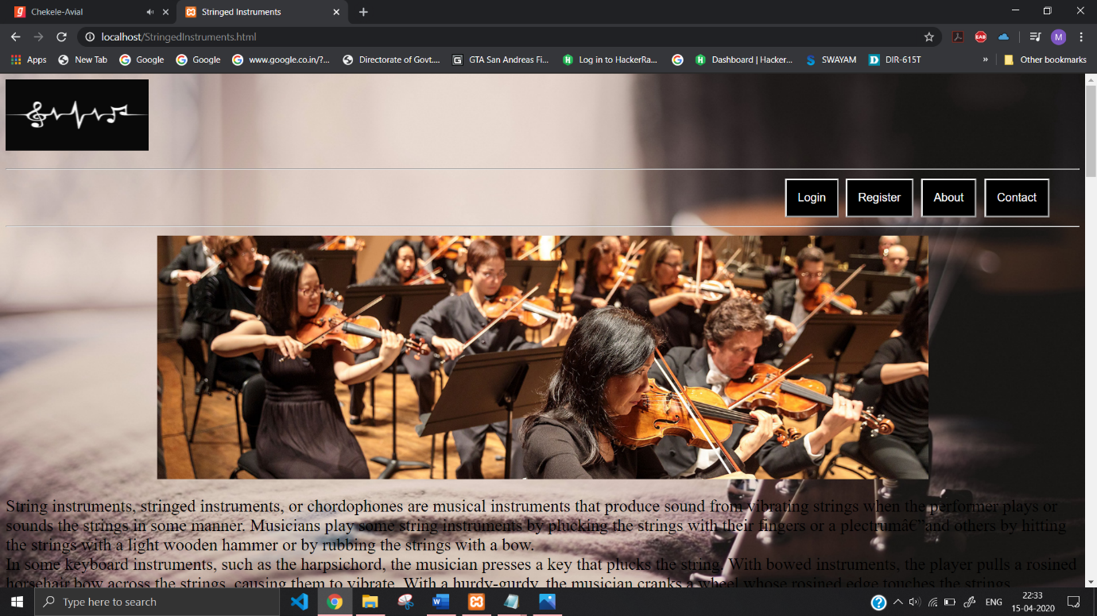

**Wind Instrument html page :**

<html>

<head>

<title>

Wind Instruments

</title>

<style>

body{

background-image:url('https://images.wallpaperscraft.com/image/gameboy_anaglyph_3d_102604_1280x720.jpg');

background-repeat:no-repeat;

background-attachment:fixed;

background-size:100% 110%;

}

.dropbtn {

background-color: rgb(0, 0, 0);

color: white;

padding: 16px;

font-size: 16px;

border: 2;

}

</style>

</head>

<body>

<big>

<p style="Color:white; font-size:25; text-align:left; image-resolution:1000"><a href="home.php"><img src="https://encrypted-tbn0.gstatic.com/images?q=tbn%3AANd9GcT_O9EvmdMKu3CtWz5K0scG6yObxkkGp4upWe7tM55u73xWK6Fe" height=100 width=200></a>

<hr>

<div>

<input class="dropbtn" type="button" onclick="location.href='Form.html'" target="_blank" value="Login" style="position: absolute; right:345">

<input class="dropbtn" type="button" onclick="location.href='RegForm.html'" target="_blank" value="Register" style="position: absolute; right:240">

<input class="dropbtn" type="button" onclick="location.href='About.html'" target="_blank" value="About" style="position: absolute; right:152">

<input class="dropbtn" type="button" onclick="location.href='Contact.html'" target="_blank" value="Contact" style="position: absolute; right:50">

<!--<input class="dropbtn" type="button" onclick="" value="" style="position:Fixed;right: 100 ">-->

</div>

<br>

<br>

<br>

<hr>

<p>

A wind instrument is a musical instrument that contains some type of resonator (usually a tube) in which a column of air is set into vibration by the player blowing into (or over) a mouthpiece set at or near the end of the resonator. <br>The pitch of the vibration is determined by the length of the tube and by manual modifications of the effective length of the vibrating column of air.<br> In the case of some wind instruments, sound is produced by blowing through a reed; others require buzzing into a metal mouthpiece.<br>

</p>

<center><img src="https://encrypted-tbn0.gstatic.com/images?q=tbn%3AANd9GcRUPreixSvbUQfYzEonWnEyRTsxVwsbvSfrcYJI5b8ePPf-w5_6"></center>

<p>

<pre>Wind instruments are typically grouped into two families:

Brass instruments (horns, trumpets, trombones, euphoniums, and tubas)

Woodwind instruments (recorders, flutes, oboes, clarinets, saxophones, and bassoons)

Although brass instruments were originally made of brass and woodwind instruments have traditionally been made of wood, the names refer to the method by which a player produces sound rather than the material of the instrument, which may vary.

In brass instruments, the player's lips vibrate, causing the air within the instrument to vibrate.

In woodwind instruments, the player either:

causes a reed to vibrate, which agitates the column of air (as in a clarinet, oboe or duduk)

blows over a fipple, across an open hole against an edge (as in a recorder or ocarina), or

blows across the edge of an open hole (as in a flute).

For example, the saxophone is typically made of brass, but is classified as a woodwind instrument because it produces sound with a vibrating reed.

On the other hand, the didgeridoo, the wooden cornett (not to be confused with the cornet, which is made of brass), and the serpent are all made of wood (or plastic tubing, in the case of modern serpents), and the olifant made from ivory, but all of them belong to the family of brass instruments because the vibrating is done by the player's lips.

In the Hornbostel-Sachs scheme of musical instrument classification, wind instruments are classed as aerophones</pre>

<center><img src="https://encrypted-tbn0.gstatic.com/images?q=tbn%3AANd9GcT9WsL8XyIqrqvsdzgXc0PjM4SqJnhkOkKobgFXn1kLTuPn4Xok"></center>

</p>

</body>

</html>

**Wind Instrument Page Screenshot:**

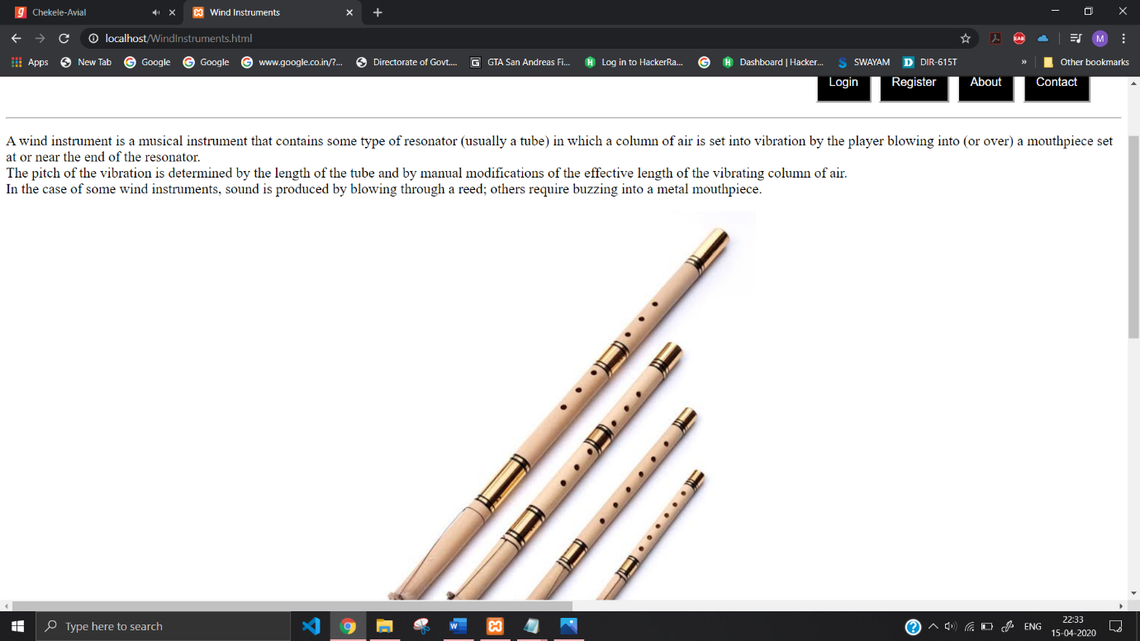

**Percussion Instruments page Html code:**

<html>

<head>

<title>

Percussion Instruments

</title>

<style>

body{

background-image:url('https://images.wallpaperscraft.com/image/parrot_vector_drawing_bright_color_95908_1280x720.jpg');

background-repeat:no-repeat;

background-attachment:fixed;

background-size:100% 110%;

font-size:"20px";

}

.dropbtn {

background-color: rgb(0, 0, 0);

color: white;

padding: 16px;

font-size: 16px;

border: 2;

}

</style>

</head>

<body>

<big>

<p style="Color:white; font-size:25; text-align:left; image-resolution:1000"><a href="home.php"><img src="https://encrypted-tbn0.gstatic.com/images?q=tbn%3AANd9GcT_O9EvmdMKu3CtWz5K0scG6yObxkkGp4upWe7tM55u73xWK6Fe" height=100 width=200></a>

<hr>

<div>

<input class="dropbtn" type="button" onclick="location.href='Form.html'" target="_blank" value="Login" style="position: absolute; right:345">

<input class="dropbtn" type="button" onclick="location.href='RegForm.html'" target="_blank" value="Register" style="position: absolute; right:240">

<input class="dropbtn" type="button" onclick="location.href='About.html'" target="_blank" value="About" style="position: absolute; right:152">

<input class="dropbtn" type="button" onclick="location.href='Contact.html'" target="_blank" value="Contact" style="position: absolute; right:50">

<!--<input class="dropbtn" type="button" onclick="" value="" style="position:Fixed;right: 100 ">-->

</div>

<br>

<br>

<br>

<hr>

<p>

A percussion instrument is a musical instrument that is sounded by being struck or scraped by a beater including attached or enclosed beaters or rattles struck, scraped or rubbed by hand or struck against another similar instrument. <br>The percussion family is believed to include the oldest musical instruments, following the human voice.<br>

The percussion section of an orchestra most commonly contains instruments such as timpani, snare drum, bass drum, cymbals, triangle and tambourine.<br> However, the section can also contain non-percussive instruments, such as whistles and sirens, or a blown conch shell. Percussive techniques can also be applied to the human body, as in body percussion. <br>On the other hand, keyboard instruments, such as the celesta, are not normally part of the percussion section, but keyboard percussion instruments such as the glockenspiel and xylophone (which do not have piano keyboards) are included.<br>

Percussion instruments are most commonly divided into two classes:<br> Pitched percussion instruments, which produce notes with an identifiable pitch, <br>and unpitched percussion instruments, which produce notes or sounds without an identifiable pitch

</p>

<p>

<center> <img src="https://www.youredm.com/wp-content/uploads/2019/03/chainsmokers-matt-mcguire-fire-drumsticks-ultra-australia-2019-rukes.jpg" width="1080px"></center>

</p>

<p>

Percussion is commonly referred to as "the backbone" or "the heartbeat" of a musical ensemble, often working in close collaboration with bass instruments, when present. <br>In jazz and other popular music ensembles, the pianist, bassist, drummer and sometimes the guitarist are referred to as the rhythm section.<br> Most classical pieces written for full orchestra since the time of Haydn and Mozart are orchestrated to place emphasis on the strings, woodwinds, and brass.<br> However, often at least one pair of timpani is included, though they rarely play continuously. <br>Rather, they serve to provide additional accents when needed.<br> In the 18th and 19th centuries, other percussion instruments (like the triangle or cymbals) have been used, again generally sparingly. <br>The use of percussion instruments became more frequent in the 20th century classical music.

In almost every style of music, percussion plays a pivotal role.<br> In military marching bands and pipes and drums, it is the beat of the bass drum that keeps the soldiers in step and at a regular speed, and it is the snare that provides that crisp, decisive air to the tune of a regiment.<br> In classic jazz, one almost immediately thinks of the distinctive rhythm of the hi-hats or the ride cymbal when the word-swing is spoken.<br> In more recent popular-music culture, it is almost impossible to name three or four rock, hip-hop, rap, funk or even soul charts or songs that do not have some sort of percussive beat keeping the tune in time.<br>

Because of the diversity of percussive instruments, it is not uncommon to find large musical ensembles composed entirely of percussion. <br>Rhythm, melody, and harmony are all represented in these ensembles.

</p>

<p>

<center><img src="https://upload.wikimedia.org/wikipedia/commons/thumb/a/ae/20070727-beleuvenissen-gocoo-11.jpg/1280px-20070727-beleuvenissen-gocoo-11.jpg"></center>

</p>

</body>

</html>

**Percussion Instruments page Screenshot:**

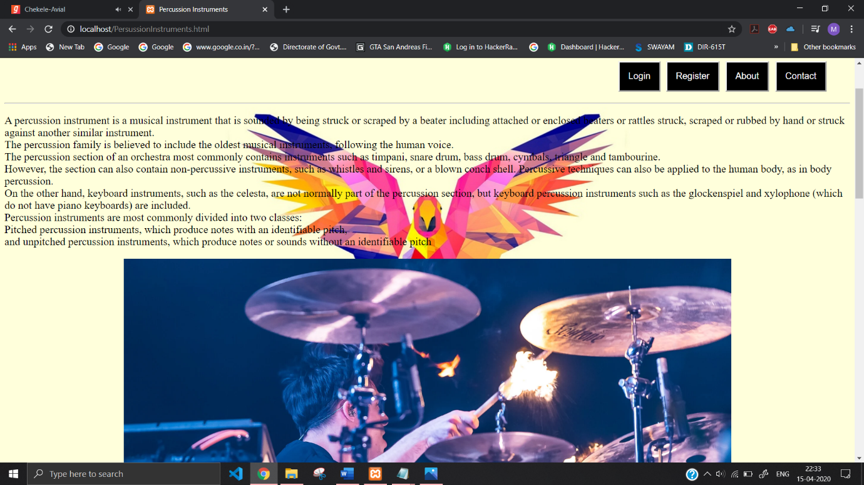

**Electronic Instruments page:**

<html>

<head>

<title>

Electronic Instruments

</title>

<style>

body{

background-image:url('https://images.wallpaperscraft.com/image/headphones_laptop_macbook_apple_107920_300x168.jpg');

background-repeat:no-repeat;

background-attachment:fixed;

background-size:100% 110%;

}

.dropbtn{

background-color: rgb(0, 0, 0);

color: white;

padding: 16px;

font-size: 16px;

border: 2;

}

</style>

</head>

<body>

<big>

<p style="Color:white; font-size:25; text-align:left; image-resolution:1000"><a href="home.php"><img src="https://encrypted-tbn0.gstatic.com/images?q=tbn%3AANd9GcT_O9EvmdMKu3CtWz5K0scG6yObxkkGp4upWe7tM55u73xWK6Fe" height=100 width=200></a>

<hr>

<div>

<input class="dropbtn" type="button" onclick="location.href='Form.html'" target="_blank" value="Login" style="position: absolute; right:345">

<input class="dropbtn" type="button" onclick="location.href='RegForm.html'" target="_blank" value="Register" style="position: absolute; right:240">

<input class="dropbtn" type="button" onclick="location.href='About.html'" target="_blank" value="About" style="position: absolute; right:152">

<input class="dropbtn" type="button" onclick="location.href='Contact.html'" target="_blank" value="Contact" style="position: absolute; right:50">

<!--<input class="dropbtn" type="button" onclick="" value="" style="position:Fixed;right: 100 ">-->

</div>

<br>

<br>

<br>

<hr>

<center><img src="https://encrypted-tbn0.gstatic.com/images?q=tbn%3AANd9GcTcgUdb0LPEHFZumILPyp2-5n-Pvuo9YY8PEooxUXN9BlwledAJ"></center>

<pre>

"Electronic instrument" redirects here. For electronic measuring instruments, see Electronic instrumentation. For other electric music instruments, see Electric instrument.

Robert Moog, inventor of the Moog synthesizer

An electronic musical instrument is a musical instrument that produces sound using electronic circuitry. Such an instrument sounds by outputting an electrical, electronic or digital audio signal that ultimately is plugged into a power amplifier which drives a loudspeaker, creating the sound heard by the performer and listener.

An electronic instrument might include a user interface for controlling its sound, often by adjusting the pitch, frequency, or duration of each note. A common user interface is the musical keyboard, which functions similarly to the keyboard on an acoustic piano, except that with an electronic keyboard, the keyboard itself does not make any sound. An electronic keyboard sends a signal to a synth module, computer or other electronic or digital sound generator, which then creates a sound. However, it is increasingly common to separate user interface and sound-generating functions into a music controller (input device) and a music synthesizer, respectively, with the two devices communicating through a musical performance description language such as MIDI or Open Sound Control.

All electronic musical instruments can be viewed as a subset of audio signal processing applications. Simple electronic musical instruments are sometimes called sound effects; the border between sound effects and actual musical instruments is often unclear.

In the 2010s, electronic musical instruments are now widely used in most styles of music. In popular music styles such as electronic dance music, almost all of the instrument sounds used in recordings are electronic instruments (e.g., bass synth, synthesizer, drum machine). Development of new electronic musical instruments, controllers, and synthesizers continues to be a highly active and interdisciplinary field of research. Specialized conferences, notably the International Conference on New Interfaces for Musical Expression, have organized to report cutting-edge work, as well as to provide a showcase for artists who perform or create music with new electronic music instruments, controllers, and synthesizers.

</pre>

<center><img src="https://encrypted-tbn0.gstatic.com/images?q=tbn%3AANd9GcRlqzOPrkV7KVcXv14V8X1gGYBkEn5JszUG--tCXiuxOK1Hzkvx"></center>

</body>

</html>

**Electronic Instruments page Screenshot:**

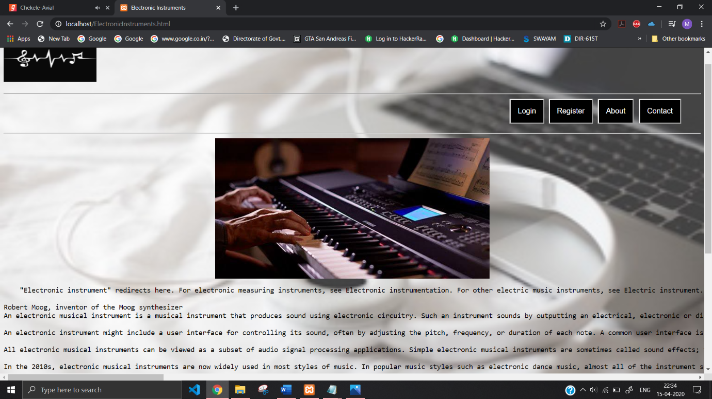

Used Local Database PhpMyAdmin:

